League Of Legends:

Data Analysis and insights

v

# 

# 

# Introduction:

League of legends is a Multiplayer Online Battleground Arena (MOBA) style game, where two teams fight in a multilane map with the objective of destroying the enemy’s nexus. Each team occupies the five positions: Top lane, Middle lane, Jungle, Attack Damage Carry(ADC)/Marksman and Support.Each player gets to select a champion to play in each game, there’s a total of 157 champions in the latest LOL version.

“

# Analysis insights:

## REQ 1: Champion pick, win, and ban rates:

We found that the top 5 most picked champions were: Jhin, MissFortune, Graves,Ezrael, and Lucian in this order. In reference to the statistics in [metasrc](https://www.metasrc.com/5v5/stats) we find that our results are not very far off from the expected given our small sample size; we found that our top picked champion Jhin was in fact the second most popular champion pick, and most champions in our top 5 were present in the top 10 most picked on the stats website.

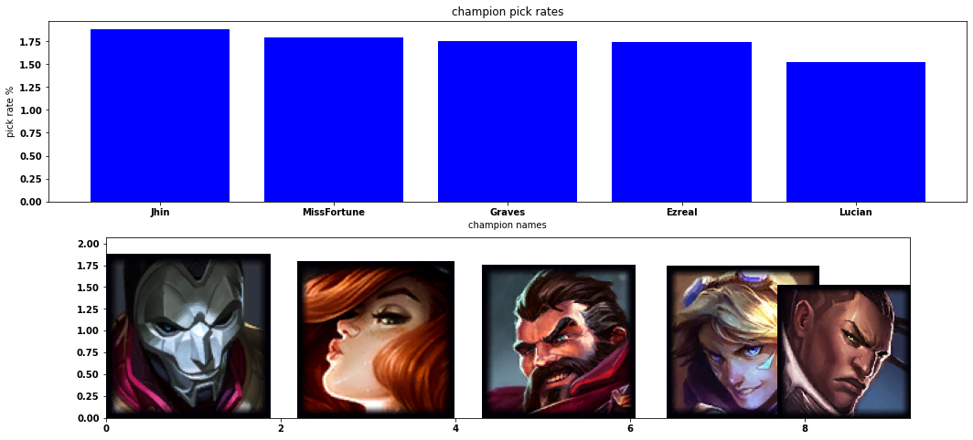

### Fig 1: top 5 most picked champions and their pick percentages

### 

### Fig 2: the champion pickrate distribution cropped for visibility, a full high resolution image is available on drive

We found that the top 5 most winning champions are: skarner, reksai, fizz ,kindred and kled. However these were only higher by a minute account. In the scope of our data the winning rate was distributed more or less uniformly with almost all champions falling somewhere between 45% and 55%. Our top 5 this time didn’t make it to the top 10. However, we know that the winrates in our dataset were very uniformly distributed and that these picks weren’t the highest win rates by any meaningful margin.

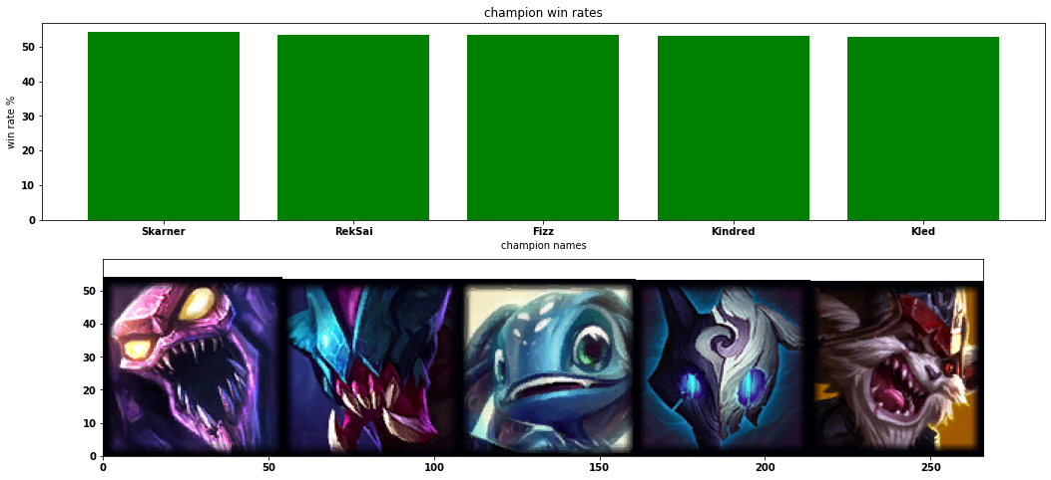

### Fig3: the top5 in winning rate

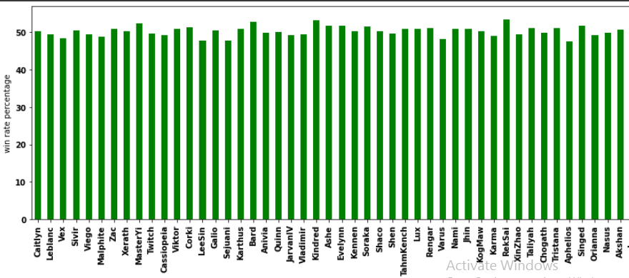

### Fig 4: sample of champions win rate distribution

We found that Yuumi, Kayne, zed, graves,and irelia were the top 5 most banned champions.This time a lot of our picks did appear in the top 5 in the global stats.

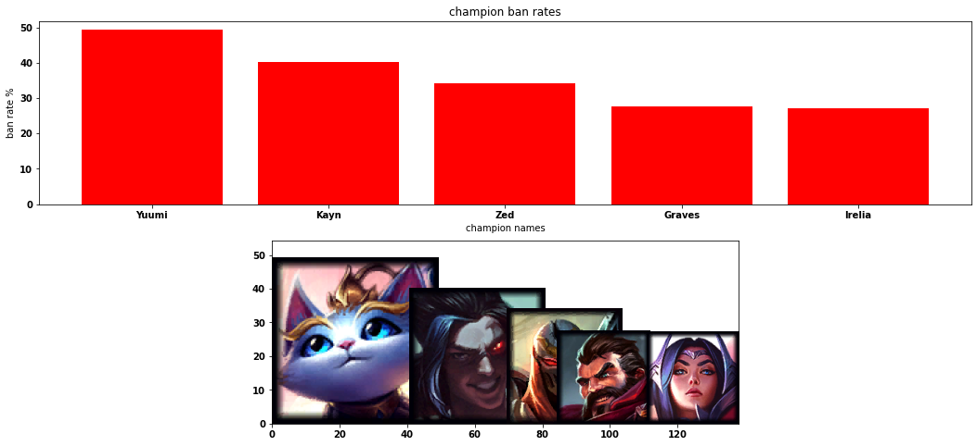

### Fig 5: the top5 banned champions

## REQ2: champion synergy:

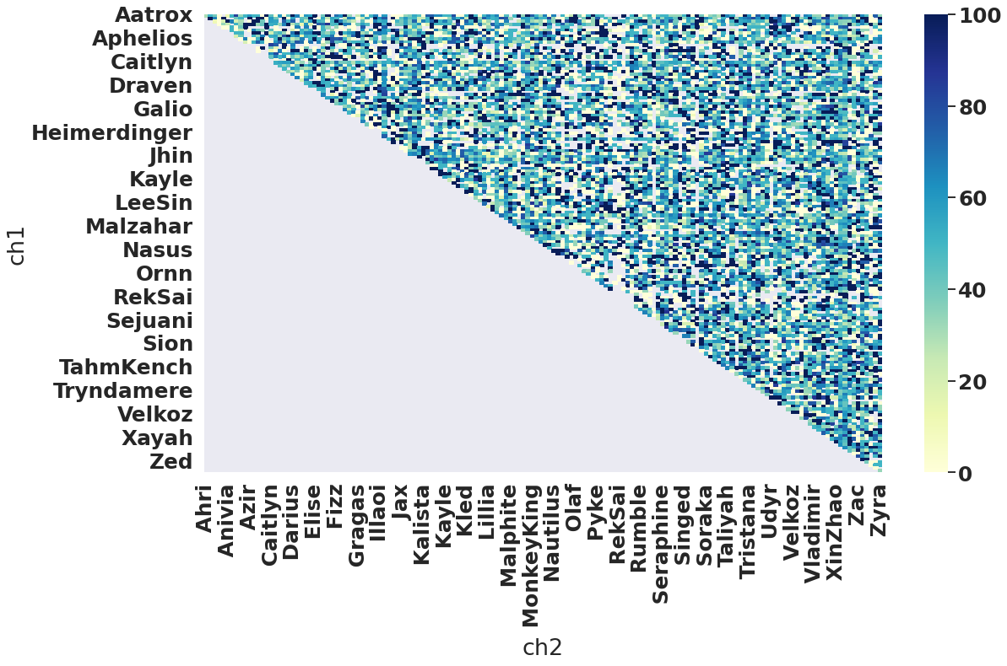

### Fig 6: heat map of the champion synergies, on the x and y access are potential champion duos the color map represents the synergy score %

We found that there were over 50 champion pairs with a 100% synergy rate. In a larger dataset we would assume that 100% synergy would not happen at all as it would be very rare for all champion pairings across a huge dataset of matches to be 100% successful, this can partially-explained by considering the cases where two champions played together for one or few times, this would result in champ synergy 100%.

## 

## REQ3: item pick and win rate

The most picked items are plates steelcaps, boots of lucidity, and berserker’s greaves in this order. 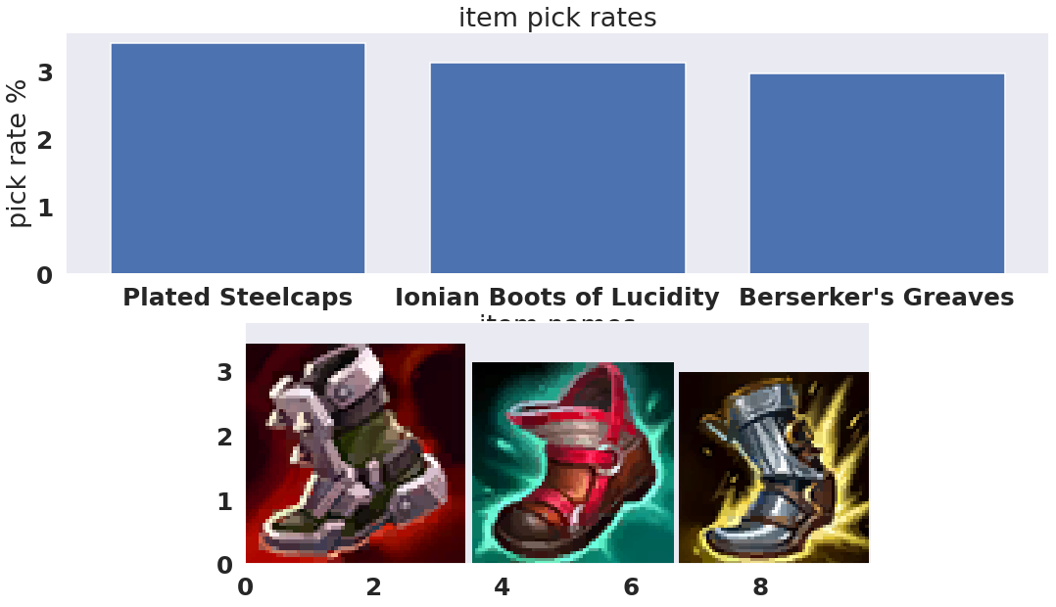

### Fig7: most picked items

While the most winning items are:

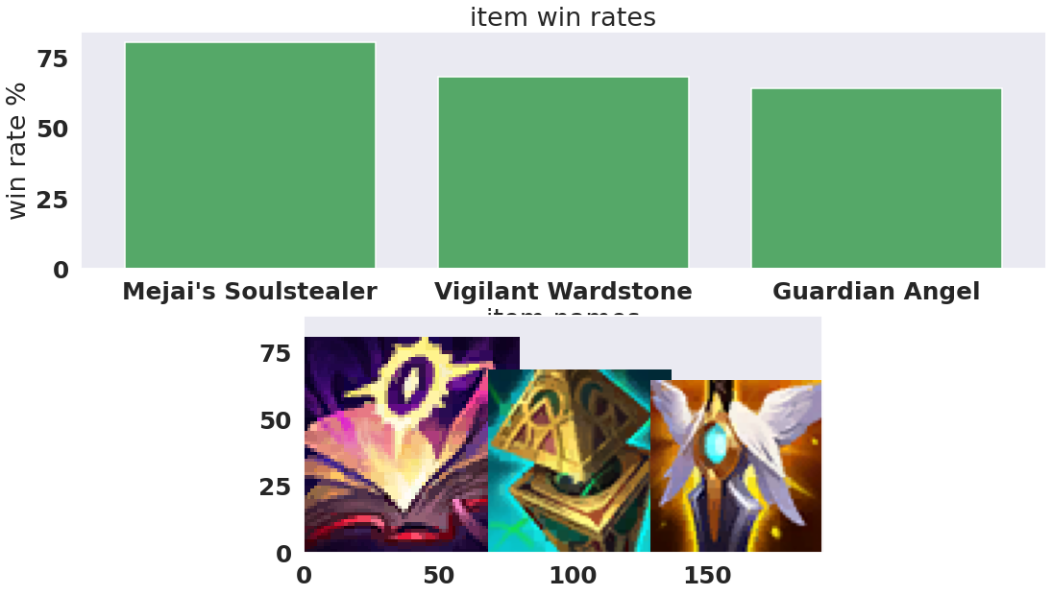

### Fig 8: most winning items.

## REQ4: item synergy

We further explored the item, as they are vital for winning, we did that with two other factors;

Item-champion pair: we found out that heart and Kennen Frozen among the highest synergies, this is consistent with the statistics.

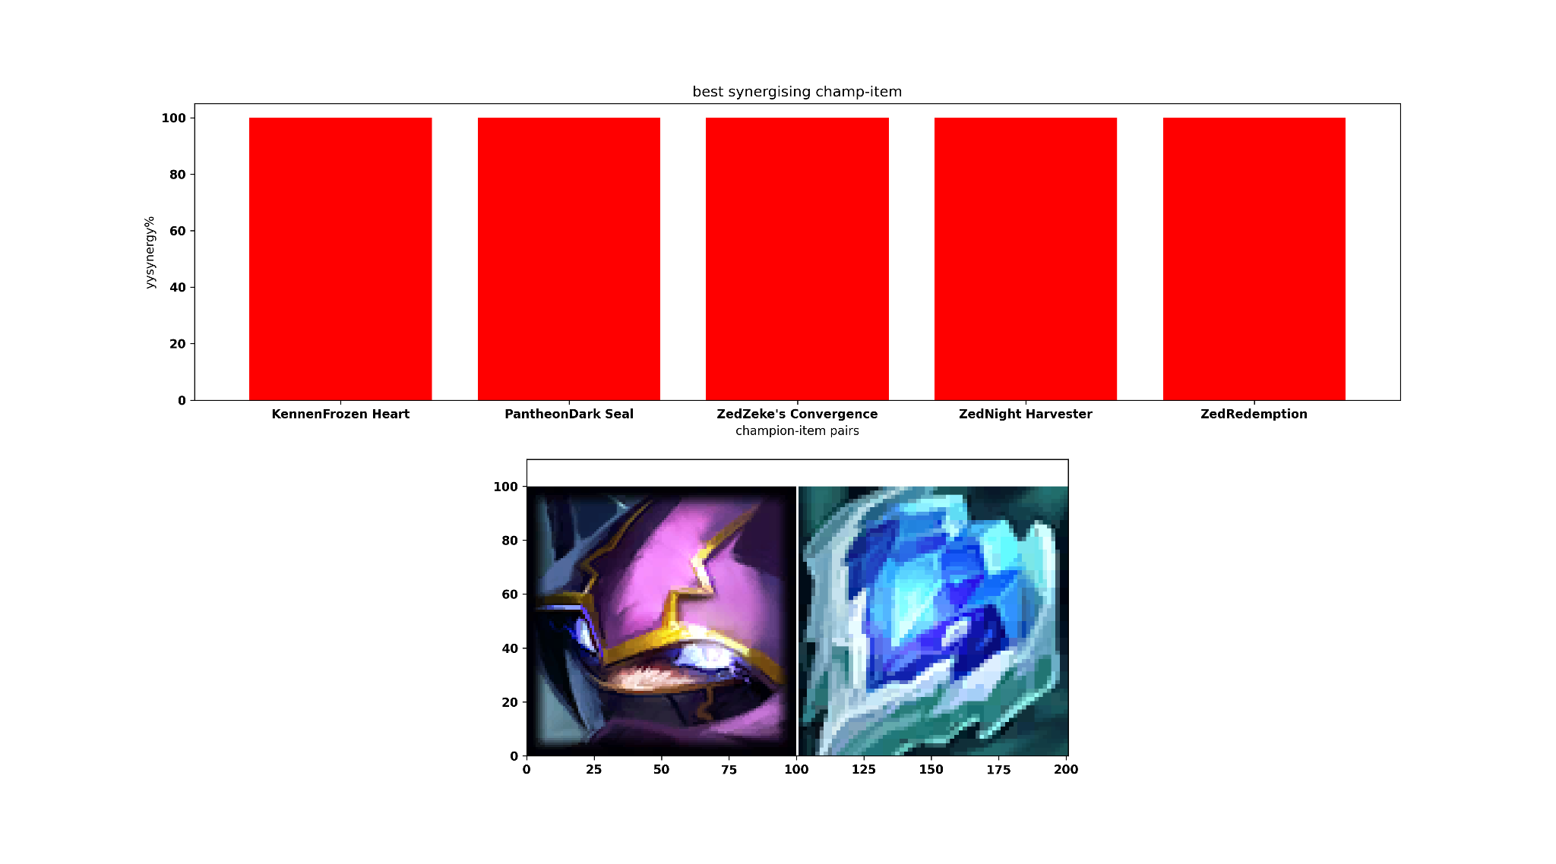

### Fig 9: highest synergizing item-champion pairs.

And Item-champion Class pair, so this gives insights about which item synergizes with certain features that gather the class members together. we found out that mejai's soulstealer and all of (a fighter, a tank, and an assassin” among those that achieved highest synergies, this is expected, since this item, according to its description [here](https://leagueoflegends.fandom.com/wiki/Mejai%27s_Soulstealer), is crucial only to those who would kill, or assist a lot.

Another insightful observation is that this item came first in fig 8 as the most winning item, this shows that our analysis is consistent together, and that this item is most probably very popularly used, not just a winning item.

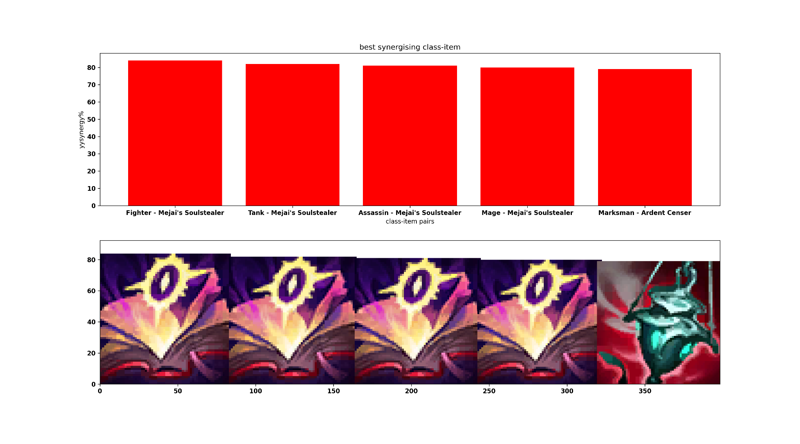

### Fig 10: highest synergizing item-class pairs.

## REQ5: item suggestion

We implemented a heuristic to suggest items to a champion to buy, taking into consideration the restrictions on the suggestion; we found those are best for the two champions ['Alistar' and 'Anivia'] respectively.

['Bulwark of the Mountain', 'Glacial Buckler', 'Stopwatch', 'Total Biscuit of Everlasting Will', 'Boots of Swiftness', 'Sheen']

['Sunfire Aegis', 'Faerie Charm', 'Boots', 'Sapphire Crystal', 'Rejuvenation Bead', 'Tiamat']

## REQ6: match result classifier

Building a Match-result predictor is very crucial, and can help in optimizing our suggestion algorithm above, specially if it’s based on our features directly correlated with winning/losing like assists, kills, death, and others, then further exploring the cruciality of each item based on this model. Our classifier did not produce a fine accuracy, however using more data would affect that drastically.

## REQ6: champion lane/win distribution

We did analysis for the champion-lane winning rate distribution, at first we were puzzled since we knew, from tutorials, that Top lane is the best, however we actually are analyzing for a single champion, while Top Lane is better for two companions, hence if you are alone, better stick with the bottom lane.

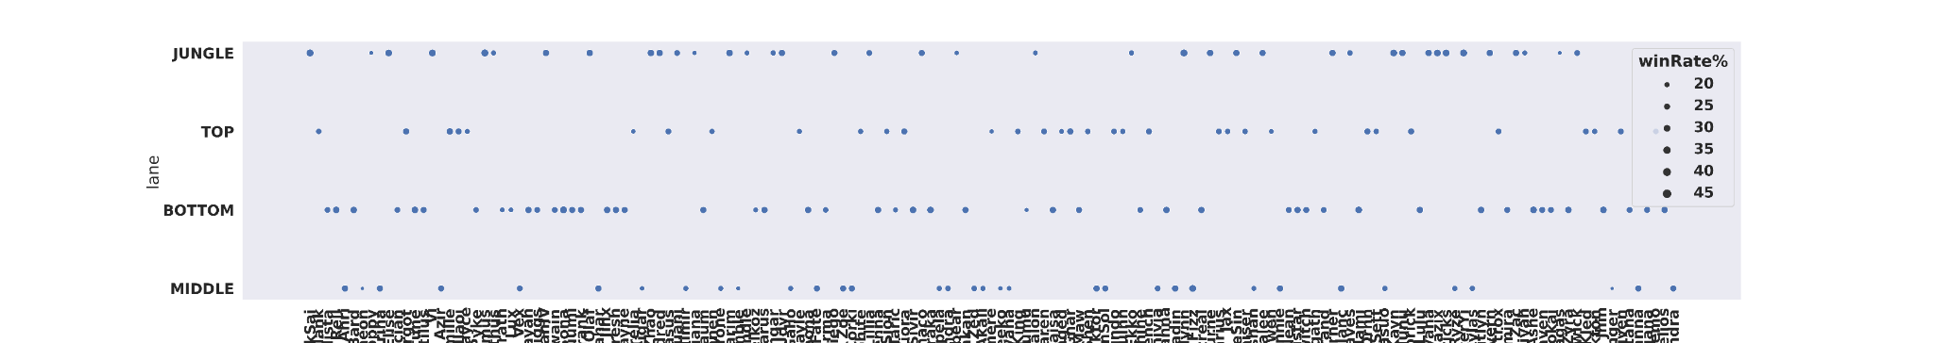

### Fig 11: champion-lane winning rate distribution.

**How can these insights be helpful?**

These insights would help in three ways; either re-orient the mentality as players and help us redirect our attention, and focus on the associated effects either those that we already know, or those indirect or on-the-long-term effects. Second as the game owner, he/she would re-consider the design of the game based on those analysis and insights, then making a more competitive, enjoyable fair game. Thirdly as a developer, he/she can build better algorithms and design more accurate heuristics for a recommendation system.

**Further analysis:**

* This can include bi-variable and multivariable analysis on things whose relation is not very obvious, like damage, death, assists, and certain items...etc.
* Since the champions are of finite number, then each single one of them can be analysed alone, an studied well, same for the items.
* The Relation between groups of champions, and their win-rate, damage..etc.
* The path taken by the winning team, taken into consideration other variables; one at a time.